
LA GRANDEE INTERNATIONAL COLLEGE
Simalchaur, Pokhara Nepal
A Project Proposal
On
“Quiz Game”

Submitted to:
Bachelor of Computer Application(BCA) Program
In partial fulfilment of the requirements for the degree of BCA under
Pokhara University
Submitted by:
Name: | Course | Semester | P.U. Registration Number
Sushant Adhikari | BCA | 2nd | 2019-00-00-1111
Miraj Puri | BCA | 2nd | 2019-00-00-1111
Prashant Tripathi | BCA | 2nd | 2019-00-00-1111
Date:06/05/2026

Acknowledgement
The satisfaction that accompanies after the successful completion of any task will be incomplete without mentioning the people whose ceaseless and relentless cooperation, constant guidance and encouragement made this project possible.
We are grateful to our project supervisor Mr Arpan Pokhrel, our faculty teacher Mr. Ramesh Chalise, for the guidance, inspiration and constructive suggestions that helped us in the preparation of this project.
We are also appreciative among each other and have understood that teamwork, the designation of the task per the skillset one portrays, constant synchronisation and monitoring of progress and instilling new knowledge and skill is imperative for the success of any given work.
Sincerely,
Sushant Adhikari
Miraj Puri
Prashant Tripathi

Declaration for
“Quiz Game”
Student’s Declaration
We hereby declare that we are the only author’s of this work and that no sources other than the listed here have been used in this work.
Name of the Students
Sushant Adhikari
Miraj Puri
Prashant Tripathi

Date: 06/05/2026

Supervisor’s Declaration
I hereby recommend that this project entitled “Project Title” is done under my supervision by Sushant Adhikari, Miraj Puri & Prashant Tripathi during their 2nd Semester in partial fulfilment of the requirements for the degree of Bachelor of Computer Application under Pokhara University is completed to my satisfaction and be processed for final evaluation.

Arpan Pokhrel
Date: 06/05/2026

Letter of Approval
We certify that we have examined this report entitled “Quiz Game” and are satisfied with the project defence. In our opinion it is satisfactory in the scope and qualify as project in partial fulfilment of the requirements for the degree of Bachelor in Computer Application under Pokhara University.

________________________  Supervisor  Arpan Pokhrel | ________________________  Examiner  Date:____ / ____ / ________ | ________________________  Program Coordinator

TABLE OF CONTENT
ACKNOWLEDGEMENT ii
STUDENT’S DECLARATION iii
SUPERVISOR’S DECLARATION iv
1. INTRODUCTION 1
2. PROBLEM STATEMENT 2
3. OBJECTIVES 3
4. METHODOLOGY 4
5. DATA FLOW DIAGRAM 5
6. PROJECT GANTT CHART/ TIMELINE CHART 6
7. DELIVERABLES 7
8. CONCLUSION 8

LIST OF FIGURES

ABBREVIATIONS
A/D | Analog-to-Digital
ABC | Atanasoff Berry Computer
ACM | Association for Computing Machinery
AI | Artificial Intelligence
ALGOL | Algorithmic Language
ALU | Arithmetic Logic Unit
AMD | Advanced Micro Devices
ARPANET | Advanced Research Project Agency Network
ASCII | American Standard Code for Information Interchange
BASIC | Beginners All-purpose Symbolic Instruction Code
BCD | Binary Coded Decimal
BIOS | Basic Input Output System
BIPS | Billions of Instructions Per Second
BPI | Bytes Per Inch
CAD | Computer Aided Design
CAE | Computer Aided Engineering
CAN | Campus Area Network
E.G. | Example

Introduction
Movie Ticket Management System is a system process whereby customers can directly purchase or book the ticket which helps to keep the records and store the customer’s details. The main purpose of this project is to provide a customer with an alternative and convenient manner to buy movie tickets as per their needs. In the existing system there are several drawbacks. So, to sort out all the existing problems this project was chosen because it provides customer with an alternative and convenient manner to buy movie tickets as per their needs. This system helps to generate the movie records to add and update it. Paper based or traditional system will be changed into computerized system which will be more helpful and reliable.

This system helps to minimize the number of staffs at the ticket counter and to increase the profit of organization. Currently, Ticket seller cannot handle all the customers at the same time if he/she is working manually. Hence, in order to reduce this problem a system is to be developed or required as per the today’s world scenario. So, for that we developed the system called Movie Ticket Management System.

For our project, we divided work between us from the beginning. Documentation and coding was divided between all of us. Mainly, Gantt chart was sketched and requirement traceability matrix was done by Roshan Bhattarai. Similarly, flowchart was graphically designed by Suman Devkota. Sushmita Gurung designed DFD. Research about project related information and testing platform and was handled by Arpan Pokhrel. However, each member contributed to the coding and testing of each module and provided their valuable inputs to improve the system.

While doing research we knew that there were many difficulties regarding collection of data, multiple seat booking, data was inaccurate, adaptation in system according to government policy was difficult while changing. By keeping these difficulties we made this system and we were successful to minimize these difficulties using C++.

Going digitally is one of the great idea in this time period because each and every thing has been digitalized and many of the work pressures will be overcome, work will be much faster and we will be able to find each and every thing in much more efficient way. We will be able to deliver a better experience for our customers.Analyzing of data will be much more easier, so going digitally is best method.

Existing system are manual so it is low and also there is high chance of data damage due to external cause, finding of customers details in need was more time consuming. For this environment we developed Movie Ticket Management System

Problem Statement
There were many difficulties as this was our first programming based project. Although there were many problems we were able to solve an implement it on our project. Lots of errors and many failures occur while attempting the entire task given in this project. Data collection, multiple seat booking, data was inaccurate, adaptation in system according to government policy and organizational change were difficult in the existing system. So to overcome these difficulties our program was intended.

At beginning people used to store/write data in manual form which results misplaced or loss of data. Previous system used to take a lot of spaces, prone to damage and being misplaced, hard to make changes, take a lot of access time, lack of security, higher cost, large ongoing staff training cost, system is dependent on good individual, misinterpretation among peoples.
List of the following issues as secondary but prominent issues – can make problem statements in both micro and macro-level.
- Data redundancies
- Paperwork(hardcopy)
- Lesser flexibility of current system
- Security
- Storage issues
- Unorganised tasks
- Out-dated technology
- Zero technology adaptation
- Few functions and functionality

Objectives
Still important and pivotal section and as everything else in the project development is centred around it, so the objectives must be clearly defined, but based on what objectives you were able to achieve, disregard the objectives you were not able to achieve. At least 7 objectives should be completed by the project.
Still, the objective should be SMART (Specific, Measurable, Achievable, Realistic, and Time-bound)
- Specific: Indicate precisely what you intend to achieve through this objective
- Measurable: What you accept as proof of project success
- Attainable: Given the resources available
- Relevant: Related to the overall goal of the project
- Time bound: Can be achieved in the given time.
Do not focus on many objectives, rather focus on what is completed.
The objectives always start from the preposition “TO” in a sentence.
Use Actionable verbs like to identify, to examine, to compare, to evaluate, to discern, to explore, to investigate, to translate, to illustrate, to justify, to assure.
Avoid weak action verbs like to study, to find out, to describe, to conclude, to see, to look into, to recommend.
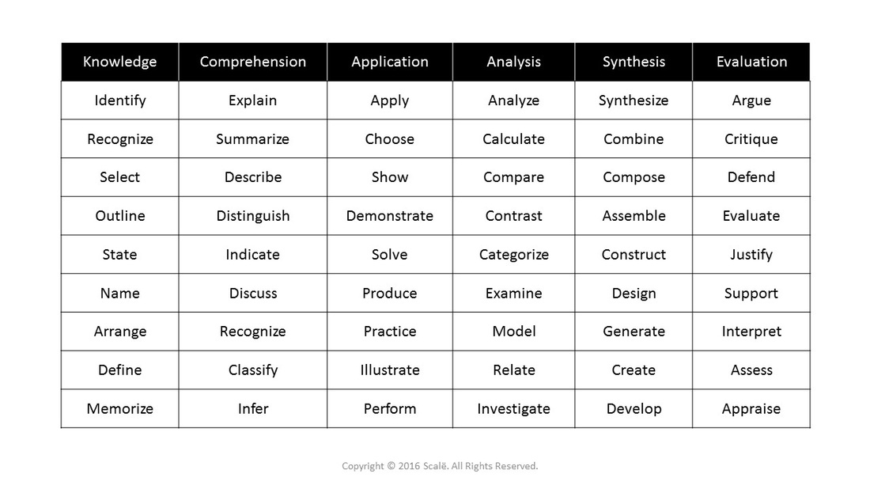
Figure 1: Actionable Verbs Examples

Background Study
The background section should discuss your findings in a chronological (Sequential Manner) manner to accentuate the progress in the field and the missing points that need to be addressed.
The project background should include information about the reasoning why you want to implement this specific project in this specific location in this specific manner. It must explain the current situation and its problems and the way in which you want to solve these problems.
May use research findings in the study, for example, traditional system is more prone to theft, loss of data, hazards, and forgetfulness. The research should be authentic, it can be from a book, website, or a scholarly article.

Requirement Document
A project cannot be implemented without proper requirements being studied; the requirements mostly are directed towards business needs for the project. Since this documentation requires complete problem-based solutions, some part of the problem statement may be repeated. The main purpose is to capture the needs which ensure that they meet the expectations of the stakeholders.
Requirements help communicate and define business needs and problems. The process involved here are requirements gathering, stakeholders establish a consensus on what is needed for customers, end users, administration’s problems to be solved. The process also can provide a basis for estimates, timelines, and, if used effectively, help prevent failures.
The benefits include:
- Alignment: Consensus and agreement among stakeholders.
- Preparation: More accurate estimates for budgets and timelines.
- Direction: Information for design, development, QA, or vendor teams.
- Efficiency: A defined plan before starting design and code work.
- Productivity: Less rework and scope creep.
Where are you headed, how long will it take, and was it a success? Requirements are the compass for the project for everyone to consult before setting sail. Start off in the correct direction, and there is a better chance the project and its participants will end up in the right place.
It does not define how to project will be created and delivered only the requirements are mentioned. The requirement document should also implement the quality control of the project, must also mention how they should implement the quality control of the project.
The best way to create a requirement document is by using a requirement matrix which prioritizes the requirements.
Requirements Matrix: A simple requirement matrix is of the following type.
SN. | Required modules, system, and features. | Description for the modules | Priority (High, Moderate, low) | Remarks
1. | Login and security system | Only the admin can login in the system | High | - Binod will look after this feature.
2. | Data entry | Data entry of the major contact details of the consumer | High | - Entire team must work here to improve the data entry system.

TYPES OF REQUIREMENTS
- Business requirements which align to high-level business goals
- Users’ requirement what the users want to do with the systems.
- Functional (Must have) requirements: the functions involved with the system.
- Non-functional requirement (not directly stated but are present in the system), these must be identified in order to improve overall workings of the system.
Segmenting the requirements based on the above-mentioned requirements will help you improve your requirements analysis and speed up the process.

System Design
You can use the system design you have created in the mid-term report, basically we need to show the system design via two methods.
- Data Flow Diagram
In the case of DFDs, do not include context level diagram rather use level-1 or level-2 DFD, given the limited time you guys have one may use the correctly amended DFD diagrams.
- Flowchart
Make sure, the flowchart encompasses all the components of the project, the best approach would be creating flow chart for the CRUD operations what you use for the data-entry, data selection, data modification and deletion.
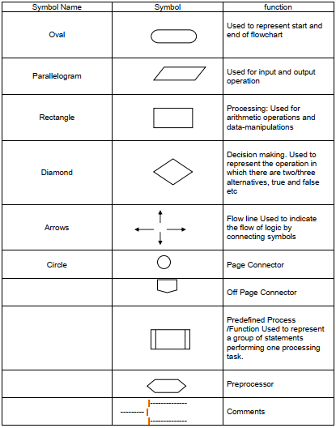
Try to use all the symbols properly, it is quite easy once you get a hang of it.

Development
Here, development refers to the model you have used for the project, for instance, waterfall, spiral, however, this section is not limited to the model only. Here, you need to describe the model you have used – SDLC.
Development may also refer to the entirety of process of planning, organizing, coordinating, and controlling the resources to accomplish specific goals. You can include the development environment (IDE) you choose and with reasons why, the tools you used for documentation, system design, and Gantt charts (or other scheduling charts).
What collaboration platform you have used, also describe the reason why, for example, you might have used SLACK, GIT or other repositories, Microsoft Teams with your project supervisor or your team members.
Do not forget the development paradigm is based on system designs too, you must religiously follow the system design and must not divert from the designs.
Finally, most importantly, the chart of work assignment.
S.N. | Name of the member | Work assigned | Remarks
1. | Your name | Documentation and coding.  - DFD  - Problem Identification  - Coding support  - Support in system design.
2. | Name | Documentation and coding.  - Gantt Chart  - Coding of login system  - Support in system design.  - Feasibility analysis.
3. | Name | Documentation and coding.  - Designed Flowchart.  - Coding for seat selection.  - Support in system design.  - Logic definition.

Testing
Mention the testing methodology you have used, make sure that we follow the testing paradigm, or software testing life cycle when we test a prototype or module.TLC stands for Software Testing Life Cycle. STLC is a sequence of different activities performed by the testing team to ensure the quality of the software or the product.
The main Motive behind Testing is that the tester or developers must be able to understand the client’s requirement, and thoroughly inspect the modules to create a positive and negative test cases.
- STLC is an integral part of Software Development Life Cycle (SDLC). But, STLC deals only with the testing phases.
- STLC starts as soon as requirements are defined or SRD (Software Requirement Document) is shared by stakeholders.
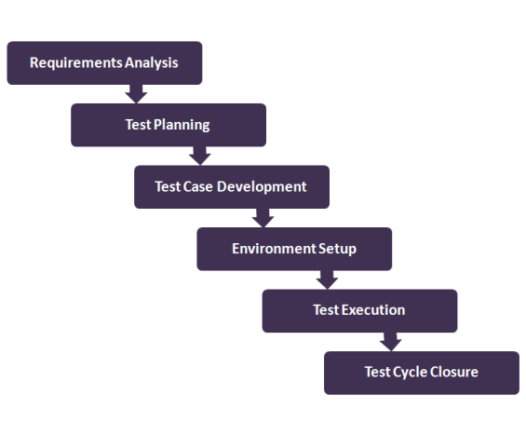
- STLC provides a step-by-step process to ensure quality software.
Figure 1: Software Testing Life Cycle
There are 6 major phases of STLC −
- Requirement Analysis − SRD is ready and shared with the stakeholders, the testing team starts high level analysis concerning the AUT (Application under Test).
- Test Planning or Execution− Test Team plans the strategy and approach, can be forward testing, backward testing, concurrent testing, modular testing.
- Test Case Designing − create the test cases based on scope and criteria.
- Test Environment Setup − When integrated environment is ready to validate the product.
- Test Execution − Real-time validation of product and finding bugs.
- Test Closure − Once testing is completed, matrix, reports, results are documented.

EXAMPLE OF A TEST CASE,
can use matrix or can use like this
Here is an example of a software test case:
Title: Module Testing of a Login function– Authentication of users
TID: 001, 002, 003
Description: A user should be able to log in with proper username and password
Precondition: The user must have username and password that is previously registered.
Test Steps:
Open the Executable file of the project, navigate to the login panel
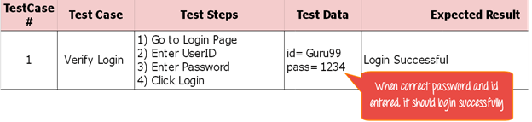
Enter random strings, zero values, null values, Capitalised strings, functions within functions, check whether it redirects to authorised sections.
Figure 2: Test Case using Matrix

A Test Matrix with Tested modules or Requirement Traceability Matrix
Requirement Traceability Matrix (RTM) is a document that maps and traces the user requirement with different test cases.
It collects all requirements addressed by the client or the requirement analysts and requirement traceability in a single document, delivered at the conclusion of the Software development life cycle.
S.N | Requirement Description | Testcase ID | Status | Remarks if any:
101 | Login into the application | TC01, TC02 | TC01- Pass  TC02- Fail | Changes needed in masking the password
102 | ID Creation | TC03 | TC03- pass | No changes required
103 | Ticket Search | TC04, TC05, TC06 | TC04- Pass  TC05- fail  TC06- Pass | Search mechanism failed.

NOTE: UAT(User Acceptance Testing) must be addressed in the final report, so here it is not required in mid-term report.
User Acceptance Testing (UAT), also known as beta or end-user testing, is defined as testing the software by the user or client to determine whether it can be accepted or not. This is the final testing performed once the functional, system and regression testing are completed.
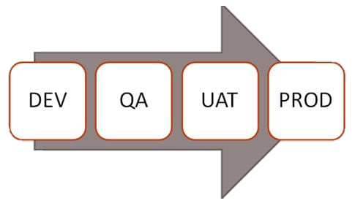
No. | Acceptance requirement(USR) | Critical (DEV) |  | Test Results(DEV) |  | Comments(USR)
 |  | Yes | No | Accept | Reject
1. | The login system should ensure security | Affirm. |  | Affirm |  | The system is felt secured.
2. | The results must be correct for inventory | Affirm. |  | Affirm. |  | The results were correct

Finally, include the user’s note or the supervisor’s note that the system works well and still a lot of updates are required for the future enhancements.

Project Results
Here in this section, you must put forward the results, on the basis of the following:
The Movie Ticket Management System project was conceptualized for the easiness during ticket purchase, food purchase as well as to end repetition, confusion during seat booking for the users. The functions which we visualized during the project were completely achieved.
The problems that have been solved with the project are:
>Time consumption during purchase of ticket and food is reduced.
>Probability of reoccurrence of booking same seat is terminated.
>Data are stored in a proper way, customer details and transaction details are quickly and comfortably found.
>Data can be copied simply and can be stored in multiple places which lower the risk of data loss.
After the background study about the manual ticketing systems, we got information about the drawbacks of manual system and by designing different features in digital system we tried to put an end to it and through our system following market necessity were met:
>Reduction in large numbers of staff in ticket counter.
>Customers are provided fast service and customers detailed were easily generated.
>After the proper management of customer details, sales report and cut off in usage of large quantities pen and papers profit is achieved.
>Data errors were speedily decreased such as repetition of customer details or forgotten of customer details.
>Clarity and consistency in operation is seen.
At the beginning of project, we were unfamiliar about the C Programming and we were having fear about the project risks. This project work has been a difficult task as well as very fruitful one as there were a lot of new and useful topics that we got to interact. This project helped us to share and present our ideas in the group as well as help us to know about “How the teamwork works”. Spiritually throughout the project journey we acquire knowledge that everything can be learnt with passion and patience. Similarly, we developed friendly bond than the beginning.

Future Enhancements
If we get enough time then we will create a new feature of mobile transaction.
- Include GUI interfaces
- Use Databases
- Use complex data structures.
- Socket programming and computer to computer networking of data
- Barcode software
- More features like data manipulation and data reporting
Basically, think of the possibilities in the future and write it down. Can be brief, or a longer paragraph to describe what can be done. It is up to you.

11. Conclusion
Final, summary of the documentation, write down the most important components and findings. of each headings.

12. Annexures
Supplementary documents, snapshots, source codes, formula, important logics, conversation with the end-users.

